GPAC Meeting Summary
February 15, 2024, 6:30-9:00 PM

Introduction

Meeting Access
All GPAC Meetings are public, and this meeting was held in person at the Petaluma Community Center. Meeting information, presentation slides, and other materials are posted on the City’s Meetings site and the Petaluma General Plan website: www.cityofpetaluma.org/meetings/ and https://www.planpetaluma.org/.

Agenda
- Welcome
- Project and Staff Updates
- GPAC Roles in Upcoming Community Engagement
  - Public Comment & GPAC Discussion
- Strategies for Making Petaluma a 15-Minute City
  - Public Comment & GPAC Discussion
- GPAC Member General Comment
- General Public Comment

Attendance
There were 12 total members of the General Plan Advisory Committee (GPAC) members in attendance, as well as members of the public. The following GPAC members were present:

- Dave Alden
- Mary Dooley
- Ali Gaylord
- Yensi Jacobo
- Sharon Kirk
- Roger Leventhal
- Roberto Rosila Mares
- Brent Newell
- Kris Rebillot
- Bill Rinehart
- Lizzie Wallack
- Bill Wolpert
The following GPAC members were absent:
- Stephanie Blake
- Phil Boyle
- Iliana Inzunza Madrigal
- Joshua Riley Simmons

The following City and consultant staff were present at the meeting:
City of Petaluma:
Brian Oh – Director of Community Development, City of Petaluma
Christina Paul – Principal Policy Planner, M-Group Consulting Planner serving the City of Petaluma
Heather Hines – Special Projects Manager, M-Group Consulting Planner serving the City of Petaluma

Consultant Team:
Ron Whitmore – Raimi + Associates
Troy Reinhalter - Raimi + Associates
Michelle Hernandez - Raimi + Associates

Meeting Summary
The focus of the 29th GPAC meeting was to discuss the role of GPAC members and working groups in upcoming community engagement and the strategies to ensure that all residents can meet most of their essential needs within a 15-minute walk of their home.

Opening
Brian Oh started the meeting by taking roll call attendance for GPAC members.

Project and Staff Updates
Christina Paul presented project and staff updates on the following topics:
- All of the Public Review Draft Policy Frameworks, except for the Land Use Policy Framework, will be released at the March GPAC meeting. The GPAC Working Groups and community members will have the opportunity to provide feedback on the draft Frameworks.
- The Planning Commission and City Council will consider the Urban Growth Boundary (UGB) ballot measure language in summer 2024. The ballot in November will be on extending the expiration date of the UGB to 2050.
- The Fairgrounds Master Plan effort will be starting in 2024 and will include a robust public engagement process. The Master Plan will be informed by the Guiding Principles developed through the Healthy Democracy project from 2023.
- The Climate Action Commission, the Planning Commission, and other City commissions and boards are reviewing the Public Review Draft of the Blueprint for Carbon Neutrality and providing feedback that will be incorporated into the final draft.
- The City is reviewing newly released State of California Sea Level Rise Guidance to understand how it can be incorporated into the adaptation strategies section. The flooding and sea level rise (SLR) mapping projections that were presented to City Council in January 2024 will not be changed as they are comparable to the new State guidance.
Please see the presentation slides and the project website (https://www.planpetaluma.org/) for more information about the project and staff updates.

GPAC Clarifying Questions & Comments
GPAC members provided the following comments after the project and staff updates.
- How does the State discuss land use in the new SLR guidance?
  - With different levels of potential flood risk, the State identifies limited examples of what could be allowed or restricted in each, but they do not define the types of structures that would be allowed or restricted. Staff are clarifying the types of structures with the State to better understand the risk to new and varied structures and development.
- Will the Fairgrounds Master Plan process be conducted by the same General Plan consultants?
  - A: No. The city will undergo an RFP process with the expectation to kick off the process at the beginning of fiscal year.
- Is there a consultant selected for the zoning code update?
  - A: It is not scoped within the General Plan consultant’s contract, and there will be an RFP process.

GPAC Roles in Upcoming Community Engagement
Brian Oh presented about the approach to upcoming community engagement on the policy frameworks as well as leadership roles for GPAC members and working groups in providing and gathering feedback on the various frameworks.

GPAC Clarifying Questions
- Has there been the thought of appointed CCB members to the GPAC?
  - A: In the very beginning of the project, the strategy taken was to appoint committee members with expertise that reflected the diversity of the city, not necessarily people who were already part of other committees.
- Older adults care about mobility, land use, and many other topics. What is the best way to bring them on board and hear their feedback?
  - A: The team will provide an online feedback method to gather feedback on the policy frameworks, but we are also working to put together in-person events that allow people with a variety of interests to provide their comments on multiple topics during the same event.
- Since the Land Use Policy Framework will not be released until later, what should the Land Use Working Group work on?
  - A: When the majority of Policy Frameworks are released, the Land Use Working Group will initially focus on the Economic Development Framework. The Land Use Policy Framework will be released with the land use alternatives so feedback can be gathered on both.

Public Comment on Agenda
The following public comments were presented after the presentation.
- Will the engagement process use any tech tools that the public can use through their phone that are not surveys? There are people who cannot come to the meetings so it would be helpful to have those remote participation methods.
- Having a banner as an advertisement for the General Plan process would get a wider range of attention on the project.
- It would be most effective to place the banner on D Street or Kentucky Street, but there should also be ads at places where people spend a couple of hours, like at service businesses. This effort could be coordinated with the Chamber of Commerce.
- As the chair of the Senior Advisory Committee, we would like representatives form all of the Working Groups to come to us, especially since we represent 32% of the population. Hoping that there is a way for 1 representative of GPAC to present and provide information on multiple topics instead of having representatives from multiple groups.
- Should also involve the non-profit organizations in town in the process.

Strategies for Making Petaluma a 15-Minute City
Troy and Ron introduced strategies to create Petaluma into a 15-minute city where residents can meet most of their essential needs within a 15-minute walk of their home. Through the Poll Everywhere survey tool, GPAC members were asked questions on strategies and policies related to each goal area to gain an understanding of preferred strategies. The results are included below, and related GPAC member comments follow.

Goal 1: Middle-Density Neighborhood Infill
Q1: To what extent should the City enable infill of existing single-family lots with up to four (4) units? Select ALL responses that you support.
Ten GPAC members responded as summarized below:
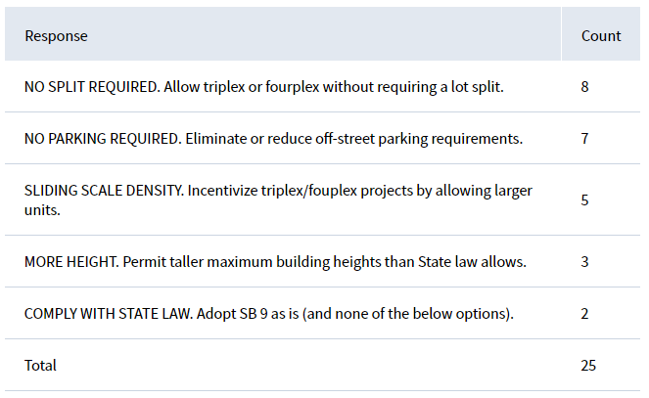
Q2: Should the City allow more than 4 units to be built on single-family lots? Note: a typical Petaluma single-family lot is approximately 5,000 square feet in size. Select ONE choice.
Ten GPAC members responded as summarized below.
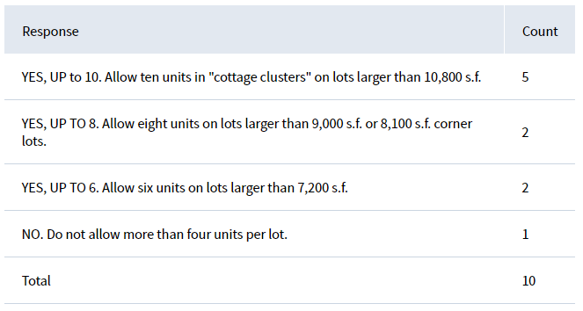

Q3: What are some other ways the City should support the evolution of residential areas? Select ALL responses that you support.
Nine GPAC members responded as summarized below:
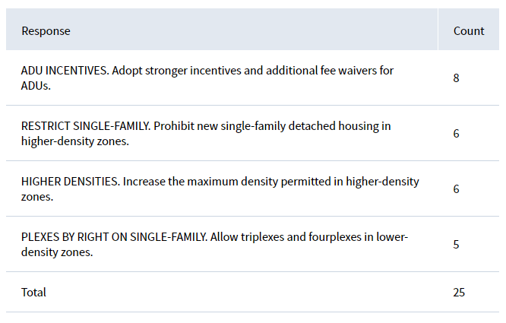

Related GPAC Member Comments
- Complying with State law for SB9: This option was chosen because it depends where the development happens and looking at Seattle as an example, it has not worked. I don’t buy into building as dense and high as we can and wouldn’t want to incentivize tearing down existing housing and rebuilding something new that doesn’t fit the context.
- It is difficult to talk about this type of development without design guidelines and context. For example, eliminating parking seems drastic, but reducing the amount required seems generally reasonable.
- If you don’t have a clear vision of what a 15-minute city might look like then eliminating parking does seem problematic, but if you do have that 15-minute city infrastructure and development pattern, then it makes sense to eliminate parking requirements.
- These strategies would make sense with some more context or if they are crafted to be context specific.
- It seems like SB9 projects have not happened because of the lot split requirement, area requirements, and the cost for initiating a lot split. Maybe also because people are not aware of this option?
- The State imposed SB9 because communities have said “no” to building more housing and denser housing for so long. As long as cities don’t change, the State will keep imposing new laws.
- Is there a middle ground between following SB9 and doing more to implement it?
  - A: Yes, the City can choose to follow SB9 or go beyond it with additional requirements or incentives.
- What does by right mean? Would projects not have to go through the Design Review Board?
  - A: If the project follows the Objective Design Standards that apply to their parcel, then yes, they would be approved without going through a design review.
- Restricting new single family development seems the way to go because that’s the only thing we’ve been building.

Goal 2: Mixing Use in Residential Neighborhoods
Q1: Should the City alter Home Occupation requirements? Select ONE response.
Ten GPAC members responded as summarized below:
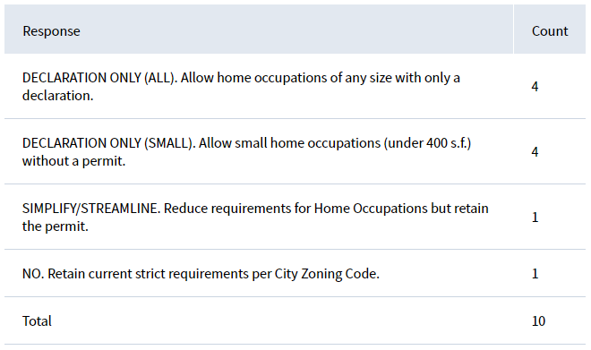
Q2: Should the City allow Live/Work everywhere or focus it in fewer areas? Select ONE response.
Seven GPAC members responded as summarized below:
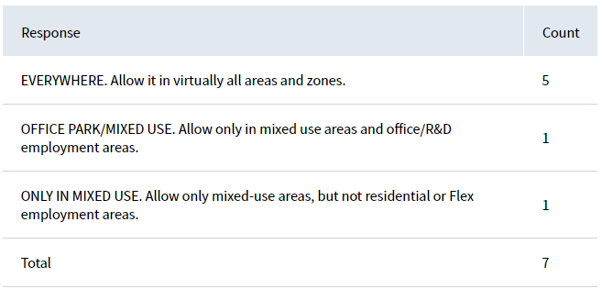
Q3: How should the City regulate Live/Work development in 15-minute centers? Select ONE response.
Seven GPAC members responded as summarized below:
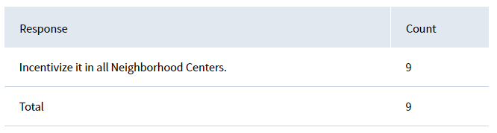
Q4: Should the City allow Live/Work uses in SB 9 neighborhood infill projects? By default, state law does not allow it. Select ONE response.
Nine GPAC members responded as summarized below:
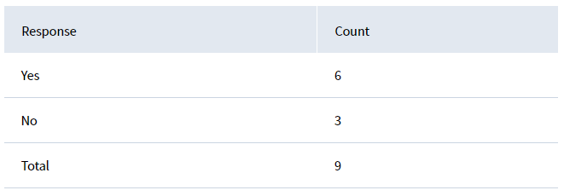

Related GPAC Member Comments
- Would there be limits on the uses allowed for home businesses? What about in live/work areas?
  - A: Yes, there would still be some use restrictions on homes businesses, but this strategy would only apply to homes businesses in single family zones.
- How do the homes business declarations work?
  - A: It is essentially an understanding or notification statement that is submitted to the local government that a resident has a home business. It allows the City to confirm the business is following any applicable guidelines or standards.
- But couldn’t the declarations for homes businesses contribute to parking issues when established retail may have no parking requirements but a building in a single family zone may have parking requirements? Or the home businesses might not follow the parking limits they are supposed to have?
- One of the important byproducts of building 15-minute neighborhoods is that services are necessarily decentralized: When we decentralize businesses lose some economies of scale, so it’s important that we enable small businesses that can thrive with a smaller set of customers as these businesses might not be able to afford commercial rents.
- Decentralizing business can have these benefits: Enables entrepreneurs to test ideas with minimal capital outlay, enables part-time entrepreneurs to fill a need while not having to earn all their income from their venture, builds community wealth, potentially inter-generational wealth, enables organic, incremental growth of our neighborhoods based on what works.
- Declaration/permit of homes businesses is essential: data collection for future policies and plans
- Could uses be limited with live/work? I would support them being everywhere if there could be limits on the work uses
  - A: Yes, live/work area can have limits on the types of non-residential uses that are allowed.

Goal 3: 15-Minute Activity Centers
Q1: Should the City be more flexible with respect to ground-floor zoning requirements? Currently, certain zones mandate the inclusion of retail spaces or storefronts in new developments. Select ONE response.
Ten GPAC members responded as summarized below:
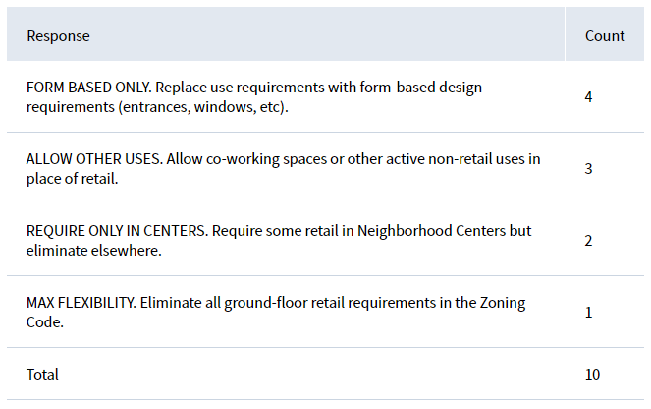

Related GPAC Member Comments
- I think we are taking the 15 minutes portion of the topic way too seriously, since uses need to be convenient, and we should instead let the market decide where things develop.
- Unclear about the 15-minute concept: One of the things that drives traffic is driving kids to school every day and going to the bigger shopping centers. The answer is probably better mobility instead of new centers. How will a neighborhood market attract people more than places they already go to? Think it should be more focused on improving the mobility
  - A: The 15-minute idea includes both improving mobility and creating new places that can meet everyday needs and be convenient.
- Casa Grande 15-minute neighborhood center: Is that property owned by the school district? There is also a shopping center a 5-minute walk down the street from that location and would suggest moving the star down there or making that whole area a 15-minute center.
  - A: There has been some interest from the district in possibly redeveloping the site.
- What’s on the top of the economic expert’s list of potential redevelopment sites?
  - A: The Lucky’s and River Plaza sites have been identified as sites that could accommodate new development.
- A core idea that came from the SDAT process was changing land uses around the city to incentivize the creation of 15-minute neighborhoods, and my impression was that as a GPAC, we were all on board with the idea, but maybe we all aren’t. It would’ve been helpful to share an introductory or background video on the 15-minute neighborhoods topic.
- We should have grocery store land trusts that allow for affordable grocery stores that are stable and reliable, so people know that it won’t go away.
- Are there any strategies to reclaim these lots that have development potential that are deep within these single family areas?
- Appreciated the comment about equity and lack of affordable housing. So far, we haven’t heard how 15 minute neighborhoods can create more affordable housing or how it is incorporating equity concerns.
  - A: One of the strategies to create more affordable and accessible housing options is to promote ADUs because they are naturally more affordable units. But this strategy doesn’t replace other affordable housing development strategies (like 100% affordable developments, inclusionary units, etc.).
- General comment on the nodes: Would recommend having the nodes more spread out around town because of the existing congestion in the center of town.

Goal 4: Supporting Infrastructure
No Poll Everywhere questions were asked about this goal.

Related GPAC Member Comments
- We realistically need to think about our mobility patterns and that instead of solely relying on bikes and walking, we should be enhancing the bus and transit routes to utilize the existing street pattern. At the nodes that occur naturally through transit routes, we should prioritize housing and back off on commercial restrictions. We need to get out of the way and let those things happen.
- Should include a goal that at public transit intersections, more flexibility should be allowed for residential and commercial uses.
- Around 70% of people are driving in and out of the city for work so the question is, how can we incentivize that to change? One option could be to attract more job centers here and attract more people to live here who already work here.
- The changes to create 15 minute neighborhoods can happen incrementally and together, the concept of 5 minute neighborhoods could happen where people have even one place to go to. It creates opportunities for people to get out of their car and start shifting their mindset about venturing out without a car.
- Many poor households spend 20% of their budget on cars, and if we can create an environment where they don’t need to utilize them, we can help alleviate some of the equity concerns around transportation.
- We could think of the nodes more as longer areas or corridors, more like clouds, especially since so much of the east side is spread out. If there were nicer walks between activity centers, much more people would be out and about.

GPAC Member General Comment
GPAC members provided the following comments at the end of the meeting:
- We are contributing to the type of characteristics we want to see in these neighborhoods through these land use decisions. It is similar to the Blue Zones initiative, so the idea of integrating Blue Zones into the General Plan process needs some more discussion.
- We need a holistic approach, systems-thinking language and supporting concepts that are overarching and easy to comprehend. We need to get into the silos to understand them but need to get out of them to really have a vision for where the city is going to go and have flexibility built into it.
- We spent a long time establishing the Vision, Pillars, and Guiding Principles and those are really our big overarching, holistic lens that we need to filter everything through. In my mind, the 15 minute city is a system that includes every aspect from that framework. It may help to have Pillars and Vision re-read or make sure GPAC members have this at top of mind at future meetings.
- Many of the topics over the last few meetings felt like we were given limited choices to make even though we talked about the ideas very broadly.
- I don’t feel comfortable going to the engagement process yet because the community does not have a lot of background on these topics, and they can’t really make a choice between 4 options without more background and context. The answers are always more complex than a yes or no question.
- One of the challenges for people who haven’t been involved in the process is that you don’t know what these changes would look like. Would like to ask for more visuals that can show these ideas and changes and provide more context for people, to really understand how it all fits together. Showing real parts of town and how it would actually change.
- Implement current technology tools with AR/VR and use Google cityscape to overlay some renderings, maybe having 3D models and overlap them on a map so people can see a physical portrayal of these large topics.
- Having examples of these concepts that are already built would help people conceptualize what change could look like.
- I thought we went through the land use element awfully quickly considering the strings attached to every parcel, there is so much more involved. We don’t fully discuss the ramifications of some of the decisions we make. For example, if we allow 4 units on a single lot that could erase single family neighborhoods and these ramifications could be harmful. Don’t think that this elimination of single family neighborhoods should happen here.
- Looking forward to this process unfolding and seeing how we address our housing challenges without SB9 or Builders’ Remedy being imposed. We should be proactively meeting housing challenges by building housing near transit centers that actually advance the equity pillar in the land use element, rather than just having a participatory and procedural justice process without any equitable outcomes.

General Public Comment
The following public comments were made at the meeting.
- This conversation was good to hear. The mixed use issue – would love to see more conversation there. I have seen developers take the streetscape and active ground floor elements and implement them in flexible ways, but they don’t want to include a space that is just retail. We need to figure out the civic design and how and why we are pushing for certain elements in new developments.
- We need that retail economist for this decentralizing retail uses conversation and for figuring out what is achievable in residential areas. Would love to see this group have time with this expert to dive into it.
- The goal of balancing income levels and jobs – this is a metric that could show a lot about the city.
- I support the idea of having a better job base to support affordability.
- We need to define 15 min neighborhoods a bit more because Petaluma has the groundwork to be one if the transportation network was better.
- We are also grappling with the climate goals and situation since a linear approach to planning is no longer relevant and we need to think of it in a systems approach. We need to take steps to meet the climate neutrality goals the city has. We also need to support a localized economy, such as allowing for more uses in 15 minute neighborhood centers.
- We have huge visions that may be different than what developers will do, we need to know what is operational now and what could be achievable in the future.
- By leaving it to the free market, the market is going to go towards the old system, and it’s our job to be visionary.
- We need to build this plan for the future and not today, as a 15 year plan, and with State population projections that there will be more older people than younger people, we need to plan for all of these people to be able to continue using this city and being able to live in it.
- As a note, there is a neighborhood center outside of the UGB.
- The node that is around the shopping center and owned by the district could be redeveloped for teachers or workforce housing.
The meeting was adjourned at approximately 9:30 PM.

